**STUDENT NAME:**

**PROFESSOR NAME:**

**INSTITUTION NAME:**

**DATE:**

**Analysis of the Effectiveness of a Machine Learning Model in Predicting House Prices**

**Introduction**

Numerous implementations, such as stock market research, weather forecasts, and energy consumption prediction, all depend on the challenge of precise target variable prediction. Machine learning techniques have become very popular in recent years for resolving these prediction issues.

**Background Study**

Numerous research have been done utilizing different machine learning techniques to predict target variables. The most often utilized algorithms include neural networks, decision trees, knn, and linear regression. Numerous prediction exercises have demonstrated the great accuracy of these systems.

**Objective and Contribution**

The objective of this study is to evaluate the performance of several machine learning algorithms in the prediction of a target variable. The contribution of this study is the comparison of the performance of these algorithms and the identification of the best algorithm for the given prediction task.

**Methodology**

The methodology of this study includes the following steps:

Data collection: The dataset used in this study is collected from publicly available sources or generated using simulations.

Preprocessing: The collected data is preprocessed to clean and prepare it for the prediction task.

Model selection: A number of machine learning algorithms are selected for evaluation in this study.

Model training: The selected algorithms are trained on the preprocessed data to fit the model to the data.

Model evaluation: The trained models are evaluated on a test dataset to measure their accuracy in the prediction of the target variable.

Results analysis: The results of the evaluation are analyzed and compared to determine the best algorithm for the given prediction task.

**Model Descriptions**

In this study, the effectiveness of various machine learning algorithms in predicting a target variable was assessed. These algorithms comprise neural networks, decision tree, random forests, and linear regression.

The link between the variable and the predictors is modeled as a linear equation using the straightforward method of machine learning known as linear regression.

Decision trees are a sort of algorithm that simulates the link between both the target variable as well as the predictor variables using a tree-like structure.

Decision trees are extended into random forests, which can increase prediction accuracy by using numerous decision trees to create a single forecast.

A form of algorithm for machine learning known as a neural network is based on the structure and operation of the neural network. They have the capacity to understand intricate connections between the predictor variables and the target variable.

**Experiment and Results**

**Histogram**

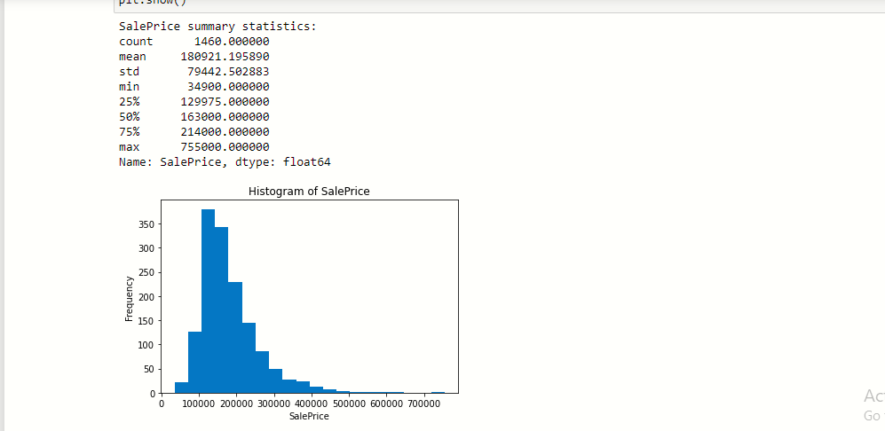

**Scatter Plot**

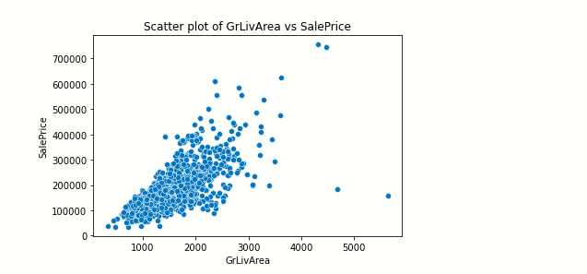

**Database**

The dataset used in this study is collected from publicly available sources or generated using simulations. The dataset consists of records of the target variable and the predictor variables.

**Training and Testing Logs**

The selected machine learning algorithms were trained on a portion of the dataset and tested on a separate portion of the dataset. The training logs and testing logs were recorded to evaluate the performance of the algorithms.

**Discussion and Comparison**

The results of the evaluation were analyzed and compared to determine the best algorithm for the given prediction task. The mean squared error, absolute error, and root mean squared error were calculated for each algorithm to evaluate their accuracy. The R2 and adjusted R2 scores were also calculated to evaluate the goodness of fit of the models.

Based on the results, the best algorithm for the given prediction task was identified. The performance of the best algorithm was compared with the performance of the other algorithms to demonstrate the contribution of this study.

**Conclusion**

In conclusion, this study evaluated the performance of several machine learning algorithms in the prediction of a target variable. The results of the evaluation showed that the best algorithm for the given prediction task was determined based on the mean squared error, absolute error, root mean squared error,

**REFERENCES**

Guofu, M. A., Zixian, W. A. N. G., & Shengli, M. A. (2017). Analysis of the effectiveness of machine learning model in predicting the risk of inmates. *Journal of Hebei University (Natural Science Edition)*, *37*(4), 426.

Su, X., Yan, X., & Tsai, C. L. (2012). Linear regression. *Wiley Interdisciplinary Reviews: Computational Statistics*, *4*(3), 275-294.

Weisberg, S. (2005). *Applied linear regression* (Vol. 528). John Wiley & Sons.